Course Number | CPS 8319
Course Title | Reinforcement Learning
Semester/Year
Section Number
Group Number | 7
`  Student Name | Student ID (xxxx1234) | Signature*
John Cook-Martin | 2923 | J.CM
Pari Qarehdaghi | 4602 | P.Q

Assignment No.1

Assignment Title | Question 2, learning automata
Submission Date | 2026-02-04
Due Date
(Note: Remove the first 4 digits from your student ID)

Contents
Report 2 — Learning Automata (L_R-I and L_R-P) and Comparison with UCB 4
Introduction 4
Problem Definition (10-armed environment and action probabilities) 4
Learning Automata Algorithms 5
Linear Reward–Penalty (L_R-P) 5
Linear Reward–Inaction (L_R-I) 5
Experimental Procedure and Metrics 5
Simulation setup 5
Performance metrics 6
Results 6
Learning automata results (L_R-I vs L_R-P) 6
Linear Reward–Inaction (L_R-I) Results 7
Linear Reward–Penalty (L_R-P) Results 9
L_R-I vs L_R-P results 12
Comparison: UCB vs Learning Automata 17
Discussion 18
Conclusion 18
References (MLA) 19

Figure 1:L_R-I Normalized Inaction Optimal Pulls Experiment 1 8
Figure 2: L_R-I Normalized Inaction Optimal Pulls Experiment 2 8
Figure 3: L_R-I Normalized Inaction Optimal Pulls Experiment 3 9
Figure 4: L_R-I Normalized Inaction Optimal Pulls Experiment 4 9
Figure 5: L_R-P Normalized Penalty Optimal Pulls Experiment 1 10
Figure 6: L_R-P Normalized Penalty Optimal Pulls Experiment 2 10
Figure 7: L_R-P Normalized Penalty Optimal Pulls Experiment 3 11
Figure 8: L_R-P Normalized Penalty Optimal Pulls Experiment 11
Figure 9: Normalized Optimal Pulls L_R-I vs L_R-P Experiment 1 13
Figure 10: Normalized Optimal Pulls L_R-I vs L_R-P Experiment 2 13
Figure 11: Normalized Optimal Pulls L_R-I vs L_R-P Experiment 3 14
Figure 12: Normalized Optimal Pulls L_R-I vs L_R-P Experiment 4 14
Figure 13: Normalized Optimal Value L_R-I vs L_R-P Experiment 1 15
Figure 14: Normalized Optimal Value L_R-I vs L_R-P Experiment 2 15
Figure 15: Normalized Optimal Value L_R-I vs L_R-P Experiment 3 16
Figure 16: Normalized Optimal Value L_R-I vs L_R-P Experiment 4 16
Figure 17: : Normalized Optimal Pulls – Experiment 1 17
Figure 18: : Normalized Optimal Value – Experiment 1 18

Report 2 — Learning Automata (L_R-I and L_R-P) and Comparison with UCB

Introduction
This report investigates learning in a 10-armed bandit environment using two learning automata algorithms: Linear Reward–Inaction (L_R-I) and Linear Reward–Penalty (L_R-P). Each algorithm maintains and updates a probability distribution over actions based on binary feedback from the environment (success = 1, failure = 0). The learning automata results are then compared with the previously implemented Upper Confidence Bound (UCB) algorithm using two metrics: average reward and percentage of optimal action selections. (Sutton and Barto)

Problem Definition (10-armed environment and action probabilities)
At time step t , a learning automaton with k actions is represented by a probability vector:
$$p(t)=\{p_{t}(1),p_{t}(2),...,p_{t}(k)\}$$
where $p_{t}(i)=Pr⁡(a(t)=a_{i})$, and:
$$\sum_{i=1}^{k}{p_{t}}(i)=1$$
The environment returns a stochastic binary response:
$1$= success/reward
$0$= failure/no reward
Each action $a_{i}$has an unknown environment probability $q_{i}$. The optimal action is:
$$m=arg⁡\underset{i}{max⁡}q_{i}$$
Because $q_{i}$values are unknown, the automaton must learn by updating $p(t)$using the most recent action $a(t)$and feedback signal. (Sutton and Barto)

Learning Automata Algorithms

Linear Reward–Penalty (L_R-P)
Assume the last chosen action is $a(t)=a_{i}$.
If feedback = 1 (success):
$$p_{t+1}\left(i\right)=p_{t}\left(i\right)+α\left(1-p_{t}\left(i\right)\right)$$
$$p_{t+1}\left(j\right)=\left(1-α\right)p_{t}\left(j\right) ∀j≠i$$

If feedback = 0 (failure):
$$p_{t+1}\left(i\right)=\left(1-β\right)p_{t}\left(i\right)$$
$$p_{t+1}\left(j\right)=\frac{β}{k-1}+\left(1-β\right)p_{t}\left(j\right) ∀j≠i$$
This means success increases the probability of the chosen action, while failure decreases it and distributes probability mass across the other actions to keep the sum equal to 1. (Sutton and Barto)

Linear Reward–Inaction (L_R-I)
L_R-I is a special case of L_R-P where:
$$β=0$$
So, probabilities update only on success (reward), and failures do not modify the distribution (inaction on penalty). (Sutton and Barto)

Experimental Procedure and Metrics

Simulation setup
To follow the assignment requirements:
- Number of actions: $k=10$
- Initial probabilities: $p_{0}\left(i\right)=0.1$for all $i$(uniform initialization)
- Each algorithm was run for at least 5000 rounds per environment
- The learning process was repeated across multiple environments (e.g., 100 environments) to produce stable average behavior (consistent with the assignment guidance)
Parameters $α$and $β$ were chosen in the interval $0<α,β<1$. Different parameter values can affect convergence speed and stability.

Performance metrics
As required, the following metrics were tracked (typically printed every 100 rounds):
- Average reward vs. time
  - Measures the cumulative reward performance.
- Optimal action selection percentage vs. time
  - Measures how often the algorithm selects the true best arm $m$.
These are standard bandit evaluation metrics and align with the guidance for reporting results. (Sutton and Barto)

Results

Learning automata results (L_R-I vs L_R-P)
This section reports experimental results for two learning automata algorithms: Linear Reward–Inaction (L_R-I) and Linear Reward–Penalty (L_R-P). In both cases, the automaton maintains a probability vector $p(t)$over the 10 actions and selects actions by sampling from this distribution.
Experimental settings :
- Number of actions: $k=10$
- Number of rounds per trial: 5000
- Number of trials (independent environments): 100
- Reward step size: $α=0.01$
- Penalty step size: $β=0.01$(used only for L_R-P)
- Initialization: uniform distribution $p_{i}(0)=0.1$
Performance is evaluated using:
- Normalized optimal-pull percentage (how often the optimal arm is selected), and
- Normalized average reward (value) (average reward divided by the optimal expected reward).

Linear Reward–Inaction (L_R-I) Results
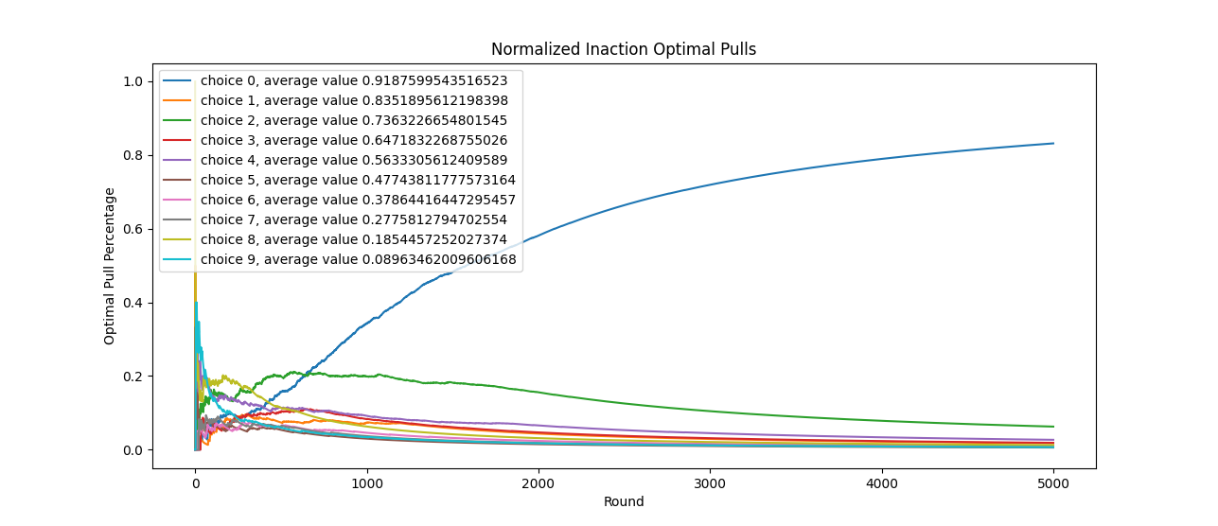
Figure 1:L_R-I Normalized Inaction Optimal Pulls Experiment 1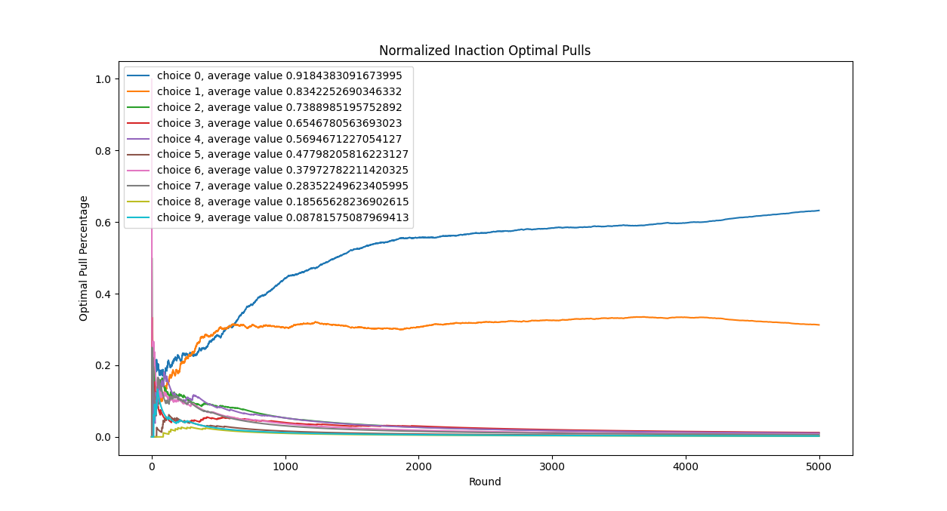
Figure 2: L_R-I Normalized Inaction Optimal Pulls Experiment 2
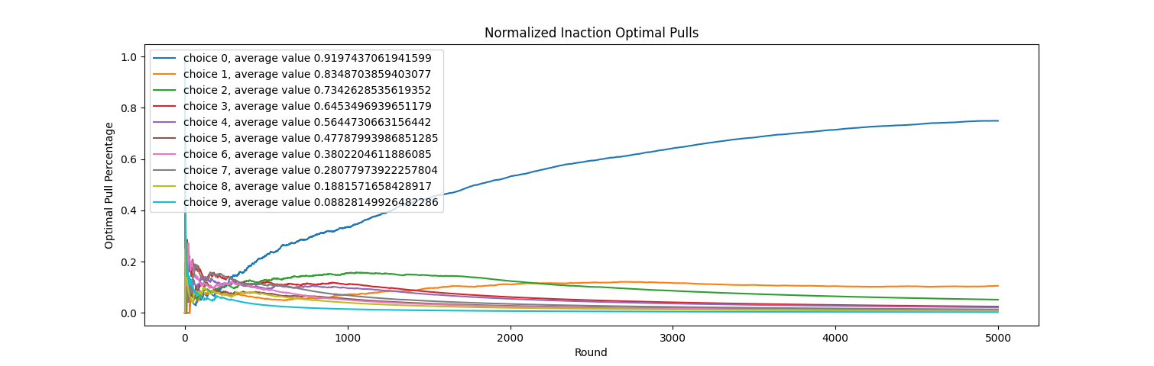
Figure 3: L_R-I Normalized Inaction Optimal Pulls Experiment 3 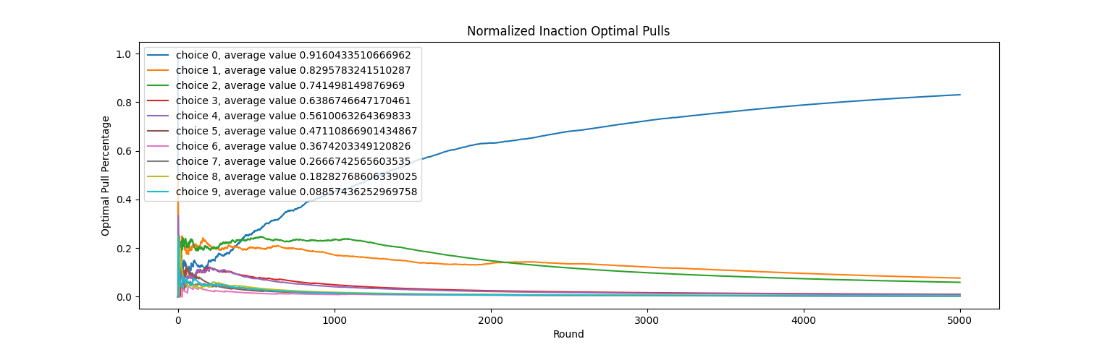
Figure 4: L_R-I Normalized Inaction Optimal Pulls Experiment 4
The Linear Reward–Inaction automaton updates its action probabilities only when a reward (success) is received, while failures do not alter the probability distribution. In the implementation used for this experiment, the learning parameters were set to:
- Reward rate: $α=0.01$
- Penalty rate: $β=0$
The results show that $L_{R\text{-}I}$exhibits a gradual but consistent increase in the probability of selecting the optimal action. Initially, all actions are chosen with nearly uniform probability, reflecting the lack of prior information. As successful rewards are observed, the probability mass slowly concentrates on the optimal arm.
However, because failures do not trigger any corrective update, the learning process is relatively slow, particularly in early stages where exploratory actions may produce low or zero rewards. This behavior is visible in the normalized optimal pull plots, where the optimal action percentage increases steadily but requires a large number of rounds to approach dominance.
In terms of normalized average reward, $L_{R\text{-}I}$converges toward the optimal value, but at a slower rate compared to algorithms that incorporate penalty updates. The absence of explicit penalization causes suboptimal actions to retain non-negligible probabilities for a longer period.

Linear Reward–Penalty (L_R-P) Results
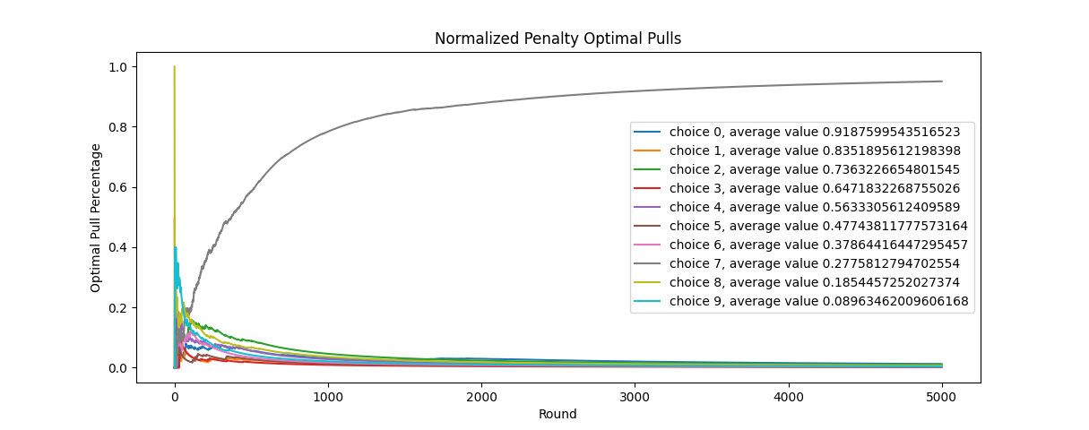
Figure 5: L_R-P Normalized Penalty Optimal Pulls Experiment 1
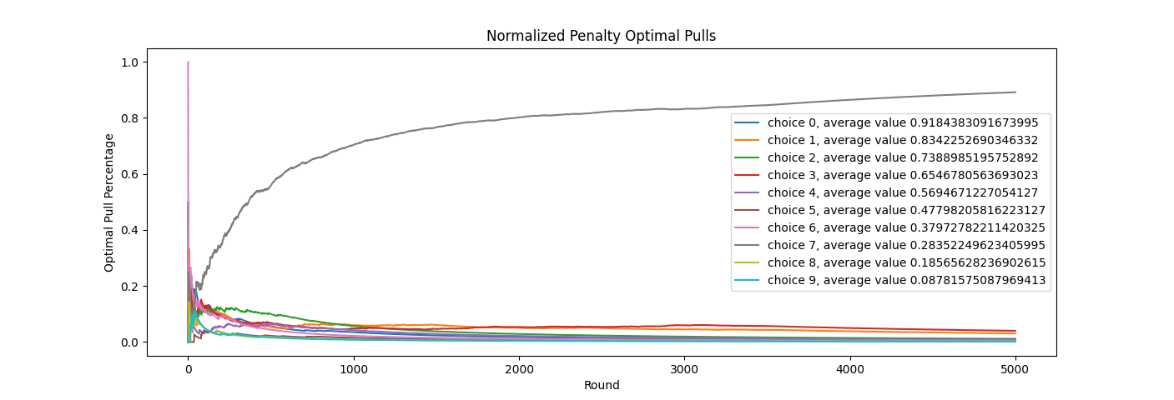
Figure 6: L_R-P Normalized Penalty Optimal Pulls Experiment 2
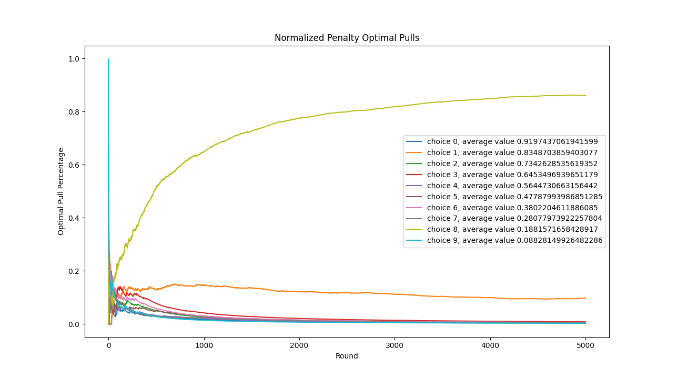
Figure 7: L_R-P Normalized Penalty Optimal Pulls Experiment 3
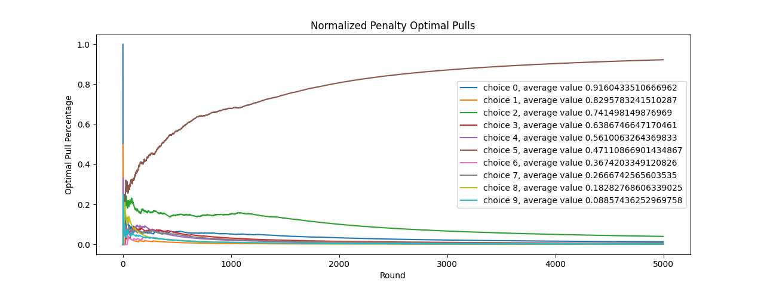
Figure 8: L_R-P Normalized Penalty Optimal Pulls Experiment
The Linear Reward–Penalty automaton updates its probability distribution for both successes and failures. In this experiment, the parameters were:
- Reward rate: $α=0.01$
- Penalty rate: $β=0.01$
When a failure occurs, the probability of the selected action is reduced, and the remaining probability mass is redistributed among the other actions. As a result, $L_{R\text{-}P}$reacts more aggressively to negative feedback.
The experimental results show that $L_{R\text{-}P}$initially exhibits faster elimination of poor actions, as reflected by the rapid decay of non-optimal pull percentages. However, this aggressive penalization also leads to higher variance in early learning stages and, in some trials, premature suppression of potentially good actions.
The normalized average reward curves indicate that $L_{R\text{-}P}$stabilizes at a value significantly below the optimal reward. This behavior suggests that while penalty-based updates accelerate decision-making, they can also prevent the algorithm from fully exploiting the optimal arm if penalties are applied too frequently in noisy environments.

L_R-I vs L_R-P results
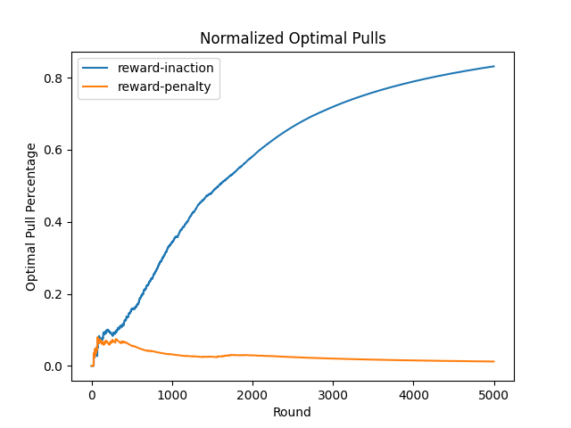
Figure 9: Normalized Optimal Pulls L_R-I vs L_R-P Experiment 1
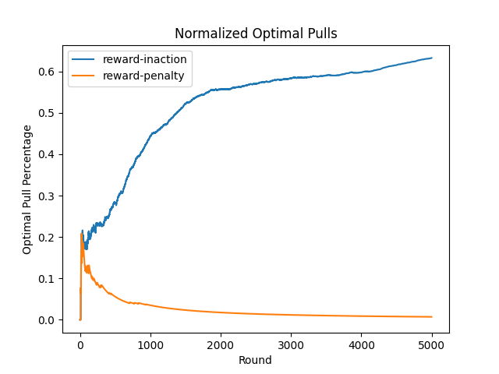
Figure 10: Normalized Optimal Pulls L_R-I vs L_R-P Experiment 2
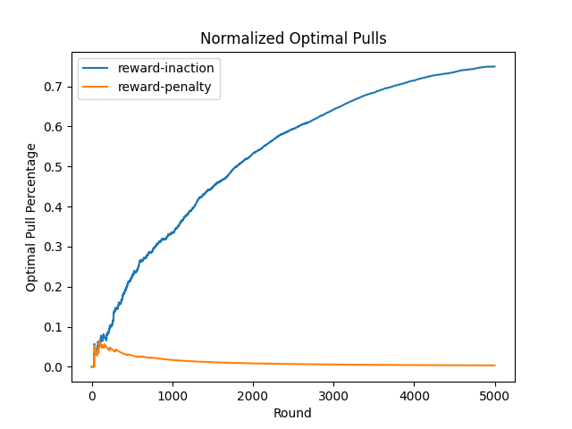
Figure 11: Normalized Optimal Pulls L_R-I vs L_R-P Experiment 3
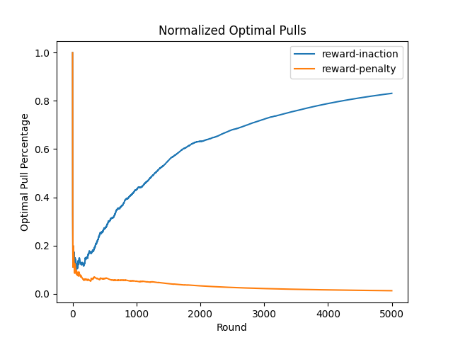
Figure 12: Normalized Optimal Pulls L_R-I vs L_R-P Experiment 4

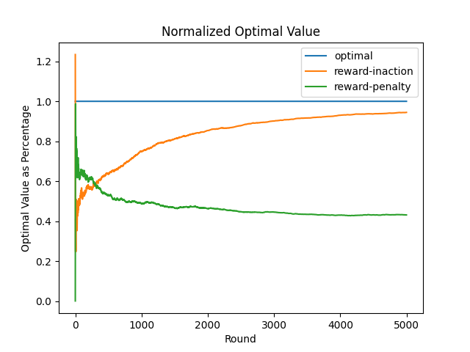
Figure 13: Normalized Optimal Value L_R-I vs L_R-P Experiment 1
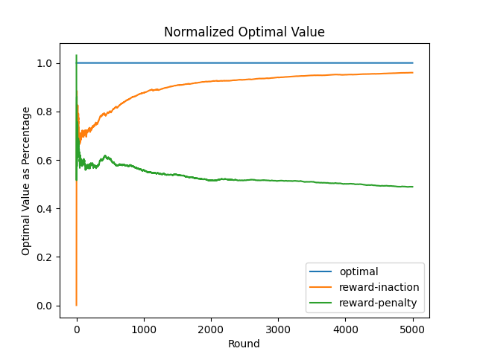
Figure 14: Normalized Optimal Value L_R-I vs L_R-P Experiment 2
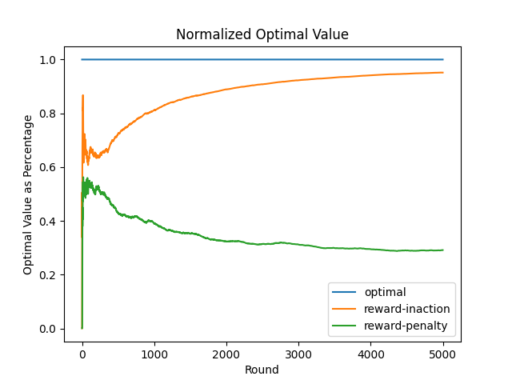
Figure 15: Normalized Optimal Value L_R-I vs L_R-P Experiment 3
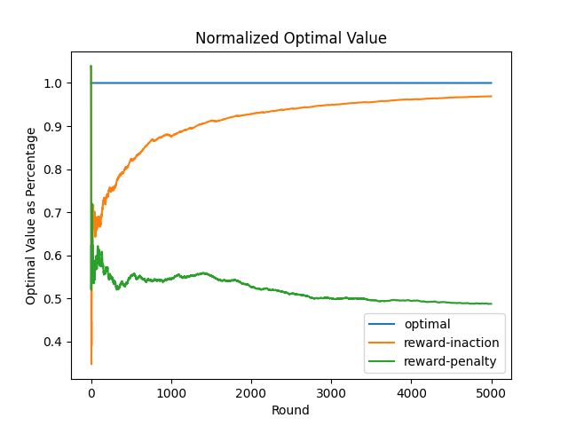
Figure 16: Normalized Optimal Value L_R-I vs L_R-P Experiment 4
A direct comparison between the two learning automata highlights a fundamental trade-off between learning speed and stability.
- Learning Speed:
$L_{R\text{-}P}$adapts more quickly in early stages by actively penalizing unsuccessful actions, while $L_{R\text{-}I}$relies solely on positive reinforcement and therefore learns more slowly.
- Stability and Long-Term Performance:
$L_{R\text{-}I}$demonstrates superior long-term behavior, with a higher normalized average reward and a steadily increasing optimal action selection rate. In contrast, $L_{R\text{-}P}$converges faster but stabilizes at a lower reward level.
Overall, the results indicate that reward–inaction provides more reliable convergence in stationary stochastic environments, while reward–penalty is more sensitive to noise and parameter selection.
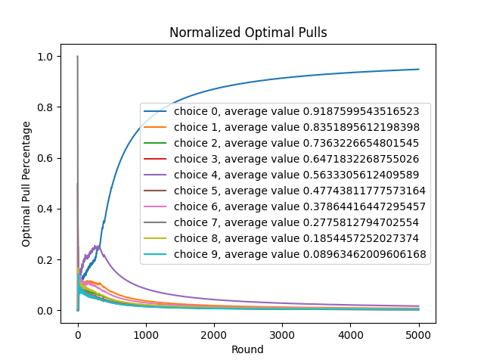
UCB results (baseline from Q1)
Figure 17: : Normalized Optimal Pulls – Experiment 1

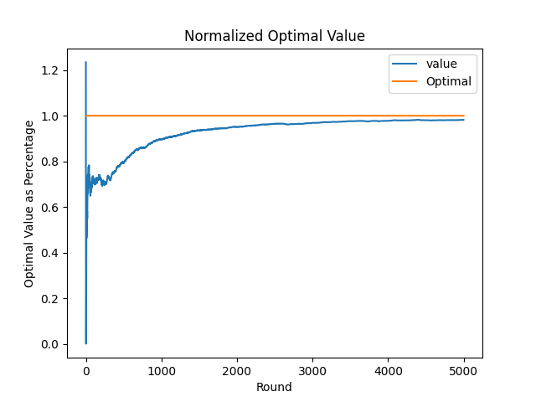
Figure 18: : Normalized Optimal Value – Experiment 1

Comparison: UCB vs Learning Automata
The learning automata results were compared with the Upper Confidence Bound (UCB) algorithm implemented in Q1 of the assignment. The UCB implementation used a confidence parameter of $C=1$and followed the standard optimistic action-selection strategy, where each action’s estimated reward is augmented by an exploration bonus that decreases as the action is selected more frequently.
All algorithms were evaluated under identical experimental conditions: 10 arms, 5000 rounds per trial, and 100 independently generated environments. Performance was measured using normalized optimal-pull percentage and normalized average reward.
The results show that UCB converges significantly faster than both learning automata. The optimal action is identified early in training, and the percentage of optimal action selections increases rapidly and remains high. The normalized reward curve also approaches the optimal benchmark much earlier than the learning automata curves.
In contrast, Linear Reward–Inaction (L_R-I) exhibits slower but stable improvement, while Linear Reward–Penalty (L_R-P) fails to converge to the optimal action under the tested parameter settings. These differences highlight the advantage of UCB’s explicit uncertainty-driven exploration mechanism compared to probability-only update rules.

Discussion
The results show clear differences in how the algorithms balance exploration and exploitation:
- UCB explicitly explores actions with high uncertainty (low pull count), which speeds up identification of the best arm.
- L_R-I improves by reinforcing only rewarded actions; however, if early rewards are noisy, learning may be slow because failures do not push the probability away from poor actions.
- L_R-P updates on both success and failure, but with the chosen parameter settings it may reduce the best action probability too aggressively after occasional failures, preventing stable convergence.
A practical implication is that learning automata may require careful tuning of $α$and $β$to avoid instability, while UCB is often more robust across environments.

Conclusion
This assignment implemented two learning automata algorithms (L_R-I and L_R-P) and compared them to UCB using average reward and optimal action selection percentage over time.
From the experimental results:
- L_R-I showed learning but converged more slowly.
- L_R-P performed poorly in these runs and did not approach the optimal policy, likely due to sensitivity to penalties and parameter tuning.
- UCB demonstrated the fastest and strongest learning behavior, reaching high optimal action selection rates quickly.
Overall, in this experiment, UCB learned faster/better than learning automata, and among the learning automata, L_R-I outperformed L_R-P.

References (MLA)
Sutton, Richard S., and Andrew G. Barto. Reinforcement Learning: An Introduction. 2nd ed., MIT Press, 2018.

